## WORKSPACE PARAMETERS

% System Parameters

m = 4;

l = 0.25;

g = 9.81;

## TASK 1: Uncontrolled 1-DOF Mechanism Using Ideal Torque Source

## Block Diagram:

## 

## Deliverables:

1. Following is the plot of input torque (N-m) and output angular displacement (rad) w.r.t. time (s)

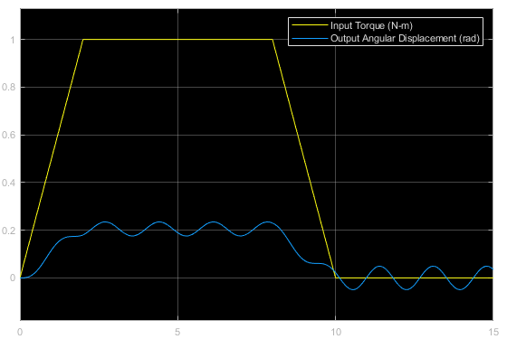

1. There are 3 possible reasons for the constant amplitude oscillations for t<10 seconds:
   * The system is uncontrolled (i.e. no corrective controller is implemented). Hence, the torque produced by the gravitational torque component opposes the driving torque produced by the ideal torque source, thereby fluctuating its value continuously.
   * A more realistic cause would be the requirement of high holding torque requirement for the mechanism (considering its inertial properties). If the driving torque produced by the ideal torque source is not sufficient to hold the mechanism in place at the desired angular position, then the opposing torque produced by the gravitational torque component will tend to dominate.
   * Lastly, the system is modelled very idealistically. There are no damping forces/torques modelled in the entire system which may dampen out these oscillations. Thus, these oscillations are observed to have a constant amplitude throughout the specified time period.
2. The time period of oscillations after t = 10 seconds is approximately 1.67 seconds.

## TASK 2: PID Controlled 1-DOF Mechanism Using Ideal Torque Source

## Block Diagram:

## 

## Deliverables:

1. Following are the PID gains after tuning:
   * KP = 67.881038334855
   * KI = 111.559002747391
   * KD = 9.00414102684276

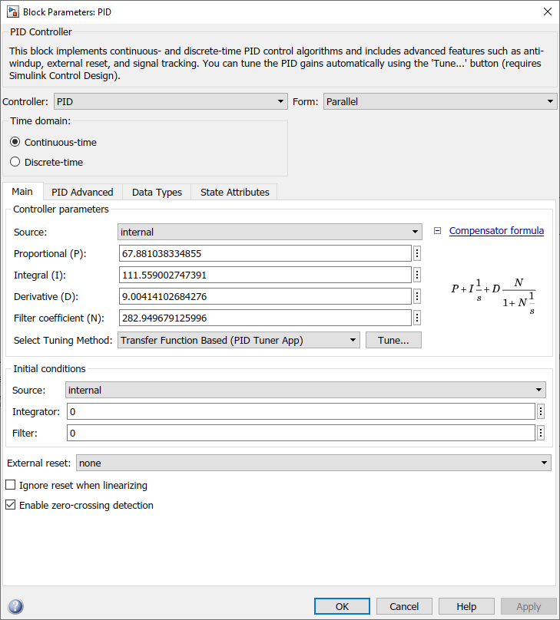

1. Following is the plot of control torque (N-m) w.r.t. time (s)

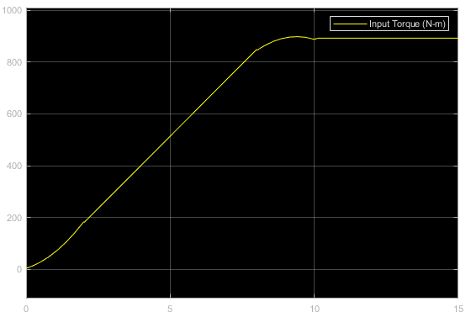

1. The maximum torque required is 898.185 N-m at t = 9.427 seconds (measured using peak finder).
2. Following is the plot of input torque (N-m) and output angular displacement (rad) w.r.t. time (s). Note that the input torque itself acts as the setpoint for the angular displacement.

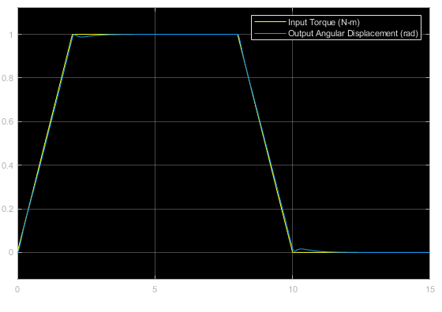

1. Following are the characteristic measurement of the control torque:

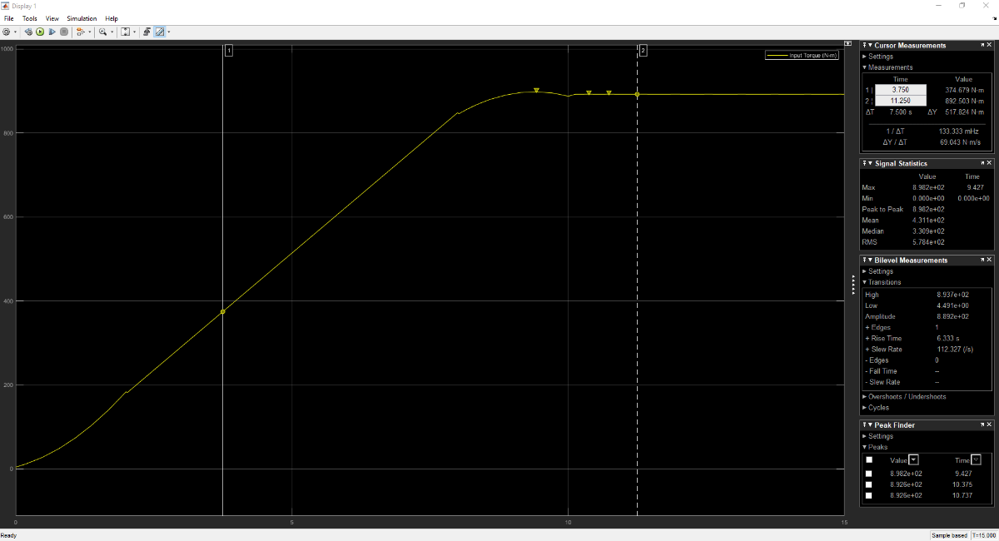

The transient characteristics of torque are:

* Rise Time: 6.333 s
* Peak Overshoot: 898.185 N-m
* Peak Time: 9.427 s
* Settling Time: 11.25 s

The transient characteristics provide us with valuable information so as to choose appropriate actuators for the system.

## TASK 3: Uncontrolled 1-DOF Mechanism Using DC Motor Model

## Block Diagram:

## 

## Deliverables:

1. Following is the plot of armature voltage (V), armature current (A), angular displacement (rad) and angular velocity (rad/s) w.r.t. time (s)

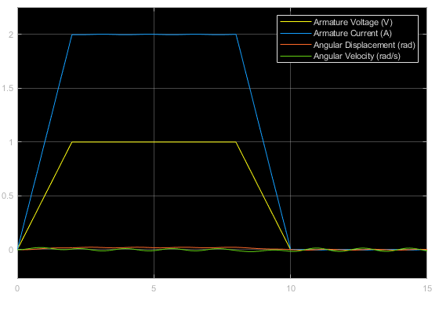

1. It can be seen that the oscillation pattern is identical in both the cases. However, the amplitude of the oscillations is reduced 10 times in case of Task 3. A possible reason for this would be the motor model converting the voltage into torque.

Following are the two plots represented side-by-side for better comparison. Note the scale of Y-axis carefully!

|  |  |
| --- | --- |
|  |  |
| Angular displacement obtained in Task 1 | Angular displacement obtained in Task 3 |

## LAB SESSION SCREENSHOT

## 

## INFERENCE

This experiment gave a deeper understanding about physical modeling (a simplified yet powerful approach to dynamic system modelling) and simulation of dynamic systems using a case study of a simple 1 DOF (rotational) mechanism, which is a typical mechatronics-based design approach. Moreover, the various tasks in this exercise helped gain a step by step knowledge about physical modeling of the said mechanism starting with minimal required components (ideal sources, inertial components (shafts), gearbox, etc.) and then gradually adding more (PID controller, motor model, etc.) to get a more detailed physical model. That being said, there is still a room for adding physical aspects such as friction, damping, drag, actuator saturation limits, etc. in order to obtain a more realistic physical model of the system.

From this experiment, it is evident that MATLAB - Simulink is a very powerful tool when it comes to modelling and simulation of dynamic systems ranging from simple 1-DOF mechanisms (as modeled and simulated in this exercise) to highly complex multi-disciplinary systems. It provides a range of built-in functions and toolboxes for rapid system analysis across multiple representation types (including Simulink as well as Physical System blocks – it is an important inference that Simulink blocks represent only numerical data whereas Physical System blocks represent a specific physical quantity along with its associated unit/dimension). Furthermore, MATLAB - Simulink is also very powerful software for control system design and offers multiple tools for fast and convenient testing (for example, convenient GUI-based PID controller tuning using Ziegler Nichols heuristic method as used in this exercise).